Nama : Syukrillah

NPM : 22552011247

Kelas : TIF RP 222PA

state = 011247 mod 7 = 5+1

jumlah input = 2n = 26 = 64

|  |  |  |  |  |  |  |  |  |  |  |
| --- | --- | --- | --- | --- | --- | --- | --- | --- | --- | --- |
|  | mod 6 | bin |  |  | mod 6 | bin |  |  | mod 6 | bin |
| 0 | 0 | 0 |  | 22 | 4 | 10110 |  | 44 | 2 | 101100 |
| 1 | 1 | 1 |  | 23 | 5 | 10111 |  | 45 | 3 | 101101 |
| 2 | 2 | 10 |  | 24 | 0 | 11000 |  | 46 | 4 | 101110 |
| 3 | 3 | 11 |  | 25 | 1 | 11001 |  | 47 | 5 | 101111 |
| 4 | 4 | 100 |  | 26 | 2 | 11010 |  | 48 | 0 | 110000 |
| 5 | 5 | 101 |  | 27 | 3 | 11011 |  | 49 | 1 | 110001 |
| 6 | 0 | 110 |  | 28 | 4 | 11100 |  | 50 | 2 | 110010 |
| 7 | 1 | 111 |  | 29 | 5 | 11101 |  | 51 | 3 | 110011 |
| 8 | 2 | 1000 |  | 30 | 0 | 11110 |  | 52 | 4 | 110100 |
| 9 | 3 | 1001 |  | 31 | 1 | 11111 |  | 53 | 5 | 110101 |
| 10 | 4 | 1010 |  | 32 | 2 | 100000 |  | 54 | 0 | 110110 |
| 11 | 5 | 1011 |  | 33 | 3 | 100001 |  | 55 | 1 | 110111 |
| 12 | 0 | 1100 |  | 34 | 4 | 100010 |  | 56 | 2 | 111000 |
| 13 | 1 | 1101 |  | 35 | 5 | 100011 |  | 57 | 3 | 111001 |
| 14 | 2 | 1110 |  | 36 | 0 | 100100 |  | 58 | 4 | 111010 |
| 15 | 3 | 1111 |  | 37 | 1 | 100101 |  | 59 | 5 | 111011 |
| 16 | 4 | 10000 |  | 38 | 2 | 100110 |  | 60 | 0 | 111100 |
| 17 | 5 | 10001 |  | 39 | 3 | 100111 |  | 61 | 1 | 111101 |
| 18 | 0 | 10010 |  | 40 | 4 | 101000 |  | 62 | 2 | 111110 |
| 19 | 1 | 10011 |  | 41 | 5 | 101001 |  | 63 | 3 | 111111 |
| 20 | 2 | 10100 |  | 42 | 0 | 101010 |  | 64 | 4 | 1000000 |
| 21 | 3 | 10101 |  | 43 | 1 | 101011 |  |  |  |  |

Mesin Moore

Q = {q0, q1, q2, q3, q4, q5}

$$ε= \{0,1\}$$

$δ=$

|  |  |  |
| --- | --- | --- |
| $$δ$$ | **0** | **1** |
| **q0** | q0 | q1 |
| **q1** | q2 | q3 |
| **q2** | q4 | q5 |
| **q3** | q0 | q1 |
| **q4** | q2 | q3 |
| **q5** | q4 | q5 |

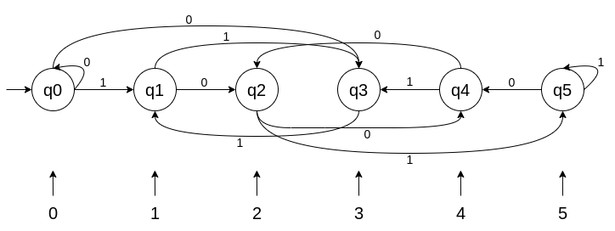

S = q0

$∆$ = {0,1,2,3,4,5}

$λ$:

$$λ=(q0)=0$$

$$λ=(q1)=1$$

$λ=(q2)=$ 2

$$λ=(q3)=3$$

$$λ=(q4)=4$$

$λ=(q5)=$ 5

Mesin Mealy

Q = {q0, q1, q2, q3, q4, q5}

$$ε= \{0,1\}$$

$δ=$

|  |  |  |
| --- | --- | --- |
| $$δ$$ | **0** | **1** |
| **q0** | q0 | q1 |
| **q1** | q2 | q3 |
| **q2** | q4 | q5 |
| **q3** | q0 | q1 |
| **q4** | q2 | q3 |
| **q5** | q4 | q5 |

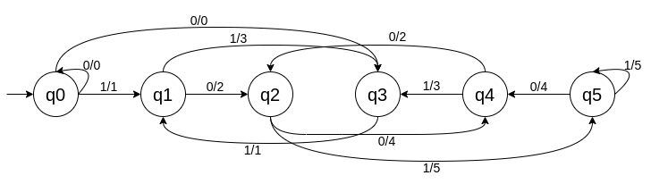

S = q0

$∆$ = {0,1,2,3,4,5}

$λ$:

$$λ=(q0,0)=0$$

$$λ=(q0,1)=1$$

$$λ=(q1,0)=2$$

$$λ=(q1,1)=3$$

$$λ=(q2,0)=4$$

$$λ=(q2,1)=5$$

$$λ=(q3,0)=0$$

$$λ=(q3,1)=1$$

$$λ=(q4,0)=2$$

$$λ=(q4,1)=3$$

$$λ=(q5,0)=4$$

$$λ=(q5,1)=5$$